­Scrum Master Report: Front End

Scrum Master: Jethro Read

Participants: Gray Hawes, Ciar Smythe, Charles Canning, Maki Kamiya, Jethro Read, Pyper McCreanor-Rupe

# Meeting Notes for Planning:

* Date: 29th Aug 2023
* Sprint Goals
  + UX/UI design file created and work upon.
  + Some MERN tech stack research for understanding.
  + GitHub Repository created with initial commit of project.
* User stories selected and their breakdown into tasks.
  + As a designer, I would like the wireframes and interactions for the website created in a design document for the team to see.

# Progress Updates throughout the Sprint:

30th Aug - Gray and Jethro have created the wireframes and some color schemes to allow the team to come to a consensus of the final website design. There are also some different logo designs (color not finalised)

After reaching a consensus, Jethro will create a final prototype before Monday in order to show the client and receive feedback.

See below for all different options created for the team to come to consensus on:

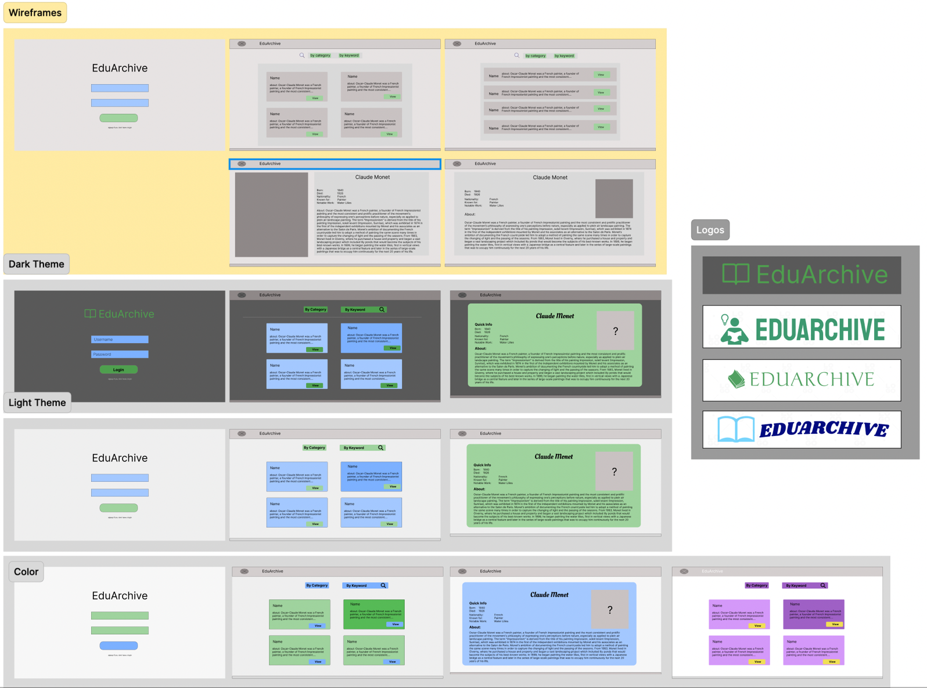

1st Sep - Team met via Microsoft Teams to discuss various items in regard to the project. Among these items we discussed the design of the application, to come to a consensus about the layouts, color themes, and logos of the application. By arriving at a Team consensus, the next step is to finalise the prototype for presentation to the client on Monday 4th Sep.

2nd Sep - Scrum Master (Jethro) created a finalised prototype to show to the Client on Monday. See Below:

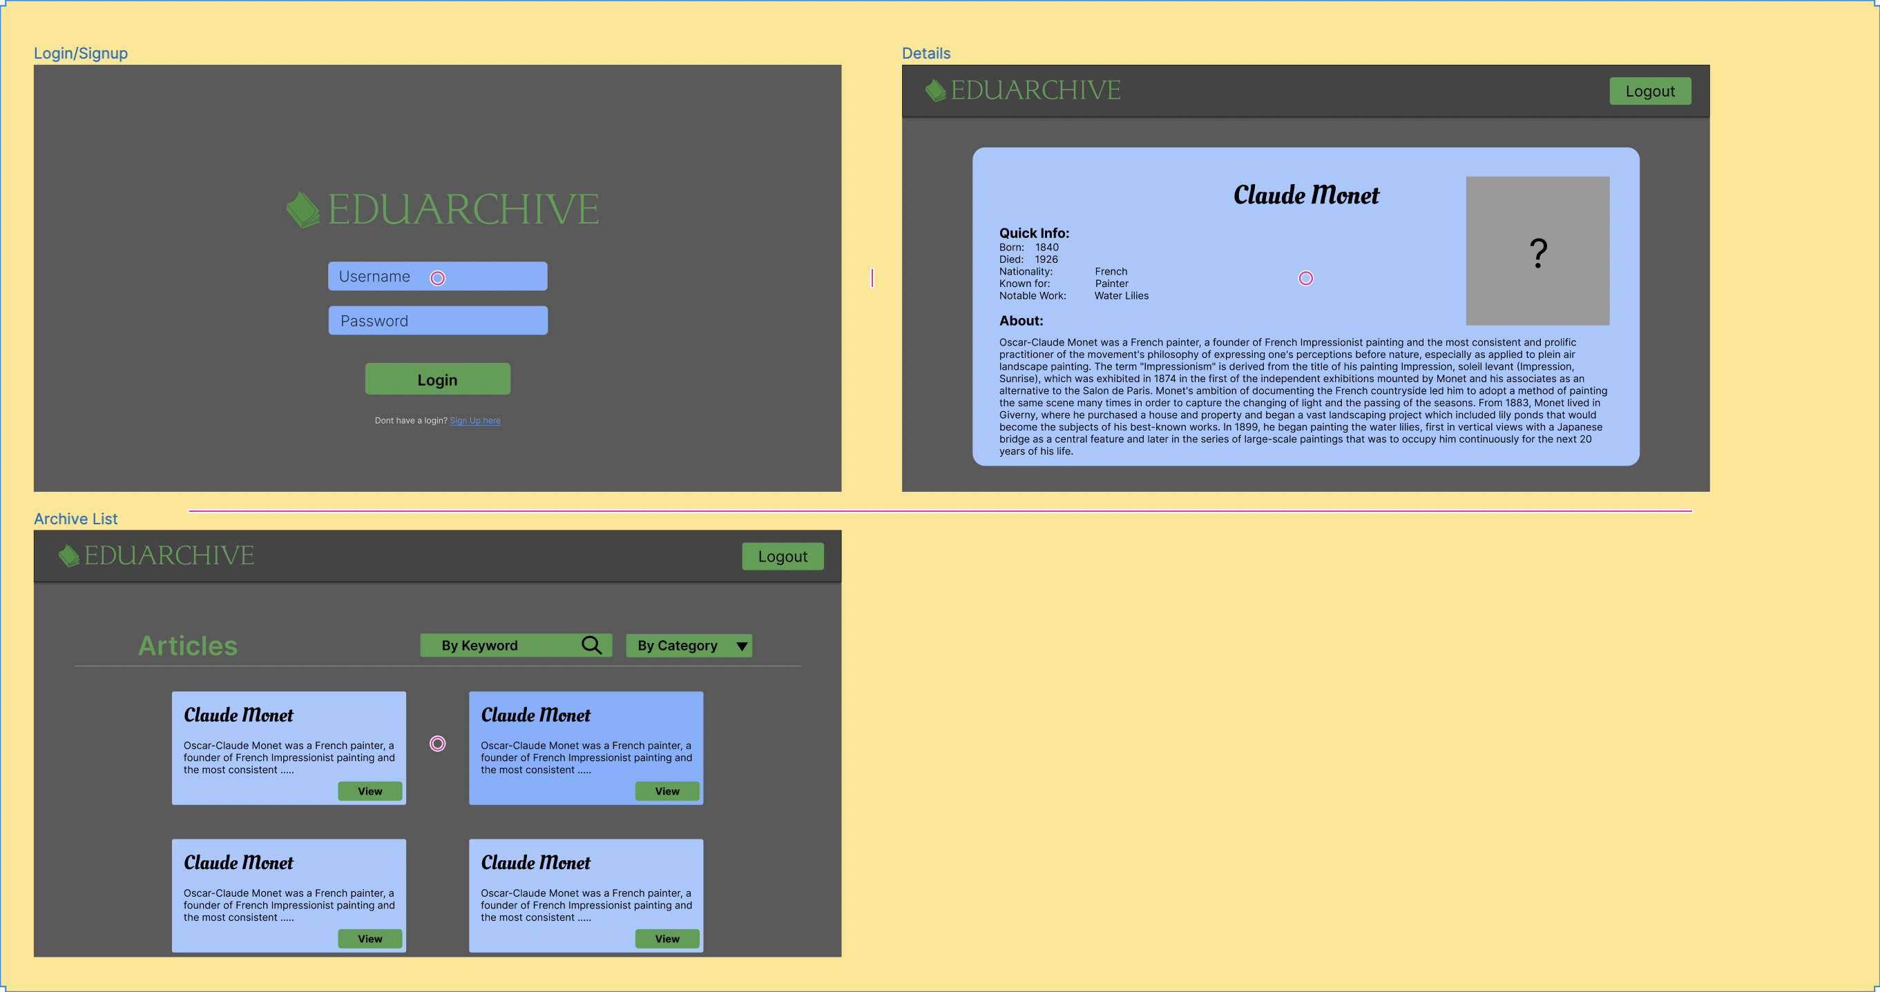

# Retrospective Notes:

* Date: 1st Friday, September 2023
* Participants: Ciar Smythe, Charles Canning, Maki Kamiya, Jethro Read, Pyper McCreanor-Rupe
* Notes for week:
  + Design Team worked together really well, bouncing ideas off each other during the design meeting on Wednesday 30th Aug. Most work was completed during this meeting due to team unavailability.
* Retrospective Notes:
  + Data Access Geeks were impressed the amount of work completed, and helped come to a consensus on the final prototypes’ design. There was some consideration regarding user permissions and CRUD operations being visible on the website, but is undecided atm.

## Accomplished:

* Created Website wireframes and color themes to create a finalised prototype to present to Client.
* Some MERN stack understanding and knowledge.

## Not accomplished:

* N/A

## What went well?

* Team members worked together and communicated well during a design meeting in order to create the design of the website.

## Action items for next sprint:

* Upload Logo to project, question Client on requirements regarding # of pages for the application. The requirements currently request for a single-page application, however the application is suited to a multi-page application with a login page, Archive List page, and Details Page. There will be more pages required if the CRUD operations are required to be on the front-end of the application.
* the development of HTML and CSS for the website in order to the database to have something to display on the application.